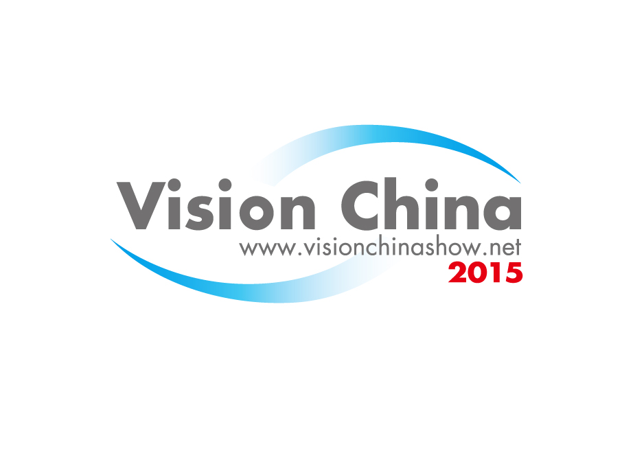

Application Form
The 12th China International Machine
Vision Exhibition and Machine Vision
Technology & Application Conference
October 14-16, 2015
China International Exhibition Center, Beijing, China

Booking Deadine:2015/09/01

Company name | Chinese
Company name | English
Address
Contact |  | Title/Department
Tel |  |  | Fax
E-mail |  |  | Website
Our company applies for：
□ Schell Scheme m2 □ Indoor Raw Space m2 □ Booth No
□ Keynote Speech sessions □ Subject Report sessions
□ Diamond Sponsorship □ Platinum Sponsorship □ Gold sponsorship
□ Advertisement Item

We observe that the application takes effect since the date when the organizer confirms it. We agree, within ten working days after receiving the confirmation letter and invoice, to remit 50% of the total cost as deposit to the organizer and the remaining shall be paid up by Sep.01,2015

Participation Cost：
Shell Scheme booth: USD 350/sqm (minimum 9sqm)
Raw Space: USD 320/sqm (minimum 18sqm)

Authorized by ：
(Signature and Seal）

Date
Please fax and mail this form to：
CIEC Exhibition Co., ltd.
Address:1/F, General Service Building, CIEC, 6 East Beisanhuan Rd, Chaoyang District, Beijing, 100028, China
Contact： Li chen (李晨)
Tel：+86-10-84600333 Fax：+86-10-84600325/0346
E-mail： lichen@ciec.com.cn/543988287@qq.com
www.visionchinashow.net

